**Mid-Term Exam**

**Windows Application Development Using C#**

**Time Allowed: 2 Hours**

Student Name: ________________________________ Student Id# _________________________

**Instructions:**

1. Make a windows application in Visual Studio and name it as **MTFirstnameLastname**.
2. Design and implement a Windows Form application that asks the user to select a car, and then displays the car name and price.
3. The **Form1** has two buttons, “**Select Your Car**” and “**Close**”, and two labels which displays the selected car’s name and price.
4. Clicking on the “Select Your Car” button displays **Form2**, which has a readonly combobox populated with car names, and two buttons “**OK**” and “**Cancel**”.
   * As long as Form 2 is displayed, user cannot go back to Form 1 without closing it.
5. On pressing “OK”, the Form2 passes the details of the selected car to Form1, which displays the details in the labels (car name and price).
   * Price is displayed in currency format.
6. On pressing “Cancel” button, Form2 closes.
7. Clicking on the “Close” button on Form1 should close the whole application. When the user closes the application, ask the user for confirmation whether they truly want to close or not.
   * The confirmation should be asked no matter how the application is closed.
   * The confirmation message should only be displayed while closing Form 1, not while closing Form 2.
8. Create a database table that stores at least 5 car names and their prices. This table should be copied to collection when Form2 loads. You can decide which collection to use, such as List, Dictionary, Stack or Queue. No grade deduction for that, as long as the application works as expected.
   * ***NOTE:*** At no point should the application save any information to disk. All information is stored and managed in memory using a collection. The use of collections and the   
     object-oriented design of the solution are an important part of the evaluation of your submission.
9. Also, populate the combobox with car names during the **Form Load** event of Form2.
   * After populating the combo-box, set the first item as “**Select car**”, and should be default selected.
10. The combobox should be styled as **DropdownList**, and the **OK** button should be disabled.
    * On selecting a car from the combobox, enable the OK button.
    * If “Select car” is selected again in the combobox, disable the OK button.
11. Following are the samples how the forms may look like. However, you are free to customize the look and feel of the forms.

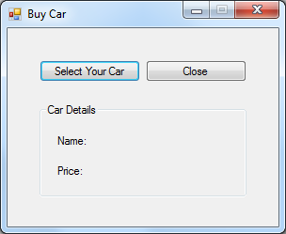 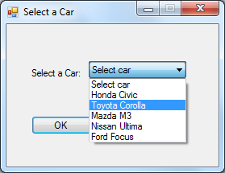 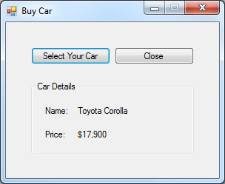

*Form 1 Form 2 Form 1*

1. Ensure all names follow the naming conventions used in class (for classes, methods, properties, variables, controls etc.).
2. Ensure both forms are displayed centered on the screen.
   * Set the title text on both the forms.
   * Disable the Maximize buttons on both the forms.
   * Set the border style to fixed, so that they cannot be resized by dragging their borders.
3. Ensure the tab order of all controls is set correctly.
4. Once you are finished, ZIP the project, and upload it into ***drop box folder on blackboard***.